**Project progress report for project with AEEC Approval nr 20210224_su_03_Macey**

06/03/2024

**Project title:** Assessing somatic growth rate and gonad development of the Cape sea urchin to evaluate the potential of sea urchin gonads as an additional product when using faecal matter from the sea urchin, *Parechinus angulosus*, as a feed/probiotic for juvenile abalone, *Haliotis midae*, in an integrated multi-trophic aquaculture system.

**Investigator(s)**: Dr Marissa Brink-Hull, Dr Mark D. Cyrus, Prof John J. Bolton, Dr Brett M. Macey

## **1.1. Purpose of the study:**

Assess the somatic growth rate and gonad development of the Cape sea urchin, *Parechinus angulosus*, as an additional value-added product from the integrated aquaculture of the Cape sea urchin and juvenile abalone.

1. Assess somatic growth and gonad development of the Cape sea urchin held in different temperatures (ambient vs 18°C).
2. Assess the effects of different diets (*Ulva*, kelp, 20U formulated feed, as well as the natural diets combined with the formulated feed) on somatic growth and gonad development of the Cape sea urchin
3. Evaluate gonad quality under the above-mentioned temperatures and feeding regimes, as well as of different sea urchin test colours, to assess the feasibility of gonad enhancement and marketability of the Cape sea urchin.

## **1.2. Background:**

The development of the aquaculture industry has resulted in concerns with regards to effluent discharge (Granada et al. 2016), reliance on natural resources as feeds or alternatively, reliance on commercial feeds, which can become costly. The implementation of integrated multi-trophic aquaculture (IMTA) systems can increase the efficiency of aquaculture systems and contribute to the development of a sustainable aquaculture industry, particularly when species that are ecologically compatible are co-cultured (Kang et al. 2003; Kim et al. 2015). In South Africa, this is possible for the high value abalone species, *Haliotis midae*, and the Cape sea urchin, *Parechinus angulosus*, as these species have a similar preferred temperature range (12 – 20 °C) (Fricke 1980; Britz et al. 1997; Day and Branch 2002a) and commonly occur together in nature, particularly during the juvenile stages of the abalone life cycle (Day and Branch 2000, 2002a).

The Cape sea urchin, *Parechinus angulosus* (Leske), is a generalist herbivore found along the South African coastline (Greenwood 1975). This species is particularly abundant in the False Bay area at shallow depths of 2 – 5 m (Griffiths 1981; Anderson et al. 1997), but can be found as deep as 20 m (Sweijd 1990). Interestingly, even though they predominantly feed on kelp (*Ecklonia maxima*) in the Western Cape region, this is not their preferred feed and they display improved digestion when feeding on red and green algae (Sweijd 1990). However, sea urchins are generally thought to have limited innate digestive enzymes capable of carbohydrate, protein and lipid metabolism and possibly rely on gut bacterial communities for these processes (Phillips 1984; Schlosser et al. 2005; Hakim et al. 2016). Therefore, the bacterial communities in the Cape sea urchin’s digestive tract likely play an endosymbiotic role to aid in digestion (Sweijd 1990).

During the early post-settlement stages of the abalone *Haliotis midae*, there is a known ecological relationship between *P. angulosus* and juvenile *H. midae* in nature, where the urchins provide the juvenile abalone with shelter and protection from predators (Day and Branch 2000). A study assessing this relationship between *P. angulosus* and *H. midae* recruits and juveniles found that juveniles are almost exclusively found under sea urchins (Day and Branch 2000) and that the removal of urchins from these areas negatively affected juvenile abalone survival (Day and Branch 2002b). In nature, the predominant feed found in *P. angulosus* and *H. midae* guts is kelp (*Ecklonia maxima*) (Day and Branch 2002a), suggesting that the juvenile abalone rely on the urchins to acquire food. However, shelter and protection might not be the only driver of the positive relationship between these species. Other factors, such as improved food supply (Day and Branch 2002b) and provision of beneficial bacterial communities from *P. angulosus* faeces could be playing advantageous roles in the development of juvenile abalone (Garland et al. 1985; Sweijd 1990).

Considering co-habitation of sea urchins and abalone in natural environments, as well as the potential symbiotic relationships that exist between them, they could be co-cultured as a method of improving animal health through the trophic transfer of microbial communities. This co-culturing concept has been assessed for sea cucumbers (*Apostichopus japonicus*) and juvenile abalone *(Haliotis discus hannai*), where the sea cucumbers feed on the food residues and faecal matter produced by the abalone (Kim et al. 2015). However, the feasibility of the Cape sea urchin as an additional value-added product has not been investigated as yet. Additionally, the effects of different temperatures and feeding regimes on the growth performance of this species has not been assessed and this information. Through the improvement of the culturing protocols for this urchin species, further value could be added to the co-culturing of sea urchins and juvenile abalone.

## **1.3. Experimental design:**

1.3.1. Culturing conditions

The sea urchins (*Parechinus angulosus*) were collected from the rock pools in front of the Marine Research Aquarium in Sea Point in May 2023. A total of 650 individuals of an average size of 4cm diameter were collected and immediately transported to plastic tanks with a flow-through system at the Marine Research Aquarium. Prior to the start of the experiment the urchins were starved for three weeks to reduce their gonad weight and ensure that all animals had a similar gonad state prior to the start of the trial. Thereafter, the urchins were stocked into oyster mesh baskets (L x W x D: 38 x 28 x 30 cm; mesh size: 6 mm) suspended in smaller plastic tanks (L x W x H: 42 x 36 x 30 cm) at 19 animals per basket (stocking density: ~ 0.6 kg m-2) and fed *Ecklonia maxima* for two weeks while they acclimatised to the experimental system. A similar test diameter size range of urchins (Table 1) were stocked in each basket across the various treatments to mitigate against growth rate differences due to different sized animals. *Parechinus angulosus* has a wide range of spinal colours (pink, light purple, dark purple, orange and red). Where possible, equal ratios of urchins with different test colours were selected for each basket.

A flow-through experimental system was utilized for the trials, consisting of 32 rectangular plastic tanks (L x W x H: 42 x 36 x 30 cm) and each tank had a volume of 40 l; when accounting for the height of the outflow. Seawater for the ambient and the heated tanks was pumped from the kelp beds in front of the DFFE Marine Research Aquarium (MRA). Before entering the experimental systems, seawater passed through a drum filter and then a sand filter prior to entering a sump tank at the highest level of the MRA. Constant aeration was provided in all tanks using airstones. Effluent water was returned directly to the ocean through the main effluent pipe of the MRA. The internal surfaces of tanks were manually cleaned of their sediments and fouling organisms twice a week, using a siphon and synthetic fibre brush.

1.3.2. Treatment regimes

Four feeding regimes were tested in quadruplicate: *Ulva lacinulata* (U), *Ecklonia maxima* kelp (K), a formulated feed containing 16% Ulva (F) (Cyrus et al., 2013), as well as a rotation of the forementioned diets (U, K, F) on a weekly basis to form a mixed diet (M), resulting in a total of 16 tanks (320 sea urchins). To ensure that feed was not a limiting factor for growth and development all feeding regimes were administered ad libitum three times a week ensuring that feed was constantly available, to avoid overfeeding, the amount of feed added at the start of the experiment was calculated as a percentage of the total body weight within each tank (U: 8%, F: 1.8%, K: 10%). Kelp fronds were cut into small segments (L x W: width of kelp frond x 5 cm) to increase surface area of feed available.

These feeding regimes were duplicated across two temperature treatments: ambient incoming temperature and 18oC. For the ambient system, water from the sump was gravity fed into the experimental tanks at a rate of ~1000 L/min (~1.5 tank turnovers/hr). Conversely, for the heated system, water from the main sump at the MRA was gravity fed into two interconnected 2,500 L JoJo tanks where the water was constantly recirculated through a heat pump set at 19 oC before entering the experimental tanks, at a rate of ~ 1000 L/min (~1.5 tank turnovers/hr). This experimental system included two temperature treatments: ambient (A: ambient) incoming water and a consistent temperature (W: warm) of 18°C (temperature controlled using a heat pump).The exact temperature in the ambient and heated experimental tanks was continuously recorded at 30-minute intervals using a temperature probe (Star Oddi Starmon Mini temperature recorder) and the average temperature over the entire experimental period was (mean ± se) 15.36 ± 0.01 oC and 18.88 ± 0.01 oC for the ambient and heated systems, respectively.

1.3.3. Data collection

• Measured sea urchins (test diameter and wet weight) to calculate growth rates across feeding regimes and temperatures every month.

• Measured feeding rates monthly.

• Monitored temperature in each tanks every half hour using an automated temperature logger probe (Star Oddi Starmon Mini temperature recorder).

• Dissected one urchin per replicate every second month to assess gonad weight, colour, and quality across feeding regimes and temperatures:

- Calculated gonad somatic index (GSI): (gonad weight/urchin weight) x 100.

- Measured gonad colour using a hand-held fibre-optic spectrophotometer (Lovibond® LC 100 spectrocolorimeter).

• Correlated gonad characteristics with urchin test colour.

• Collected faecal matter when tanks are cleaned for faecal matter nutritional component assessment.

## **1.4. Results:**

1.4.1. Survival

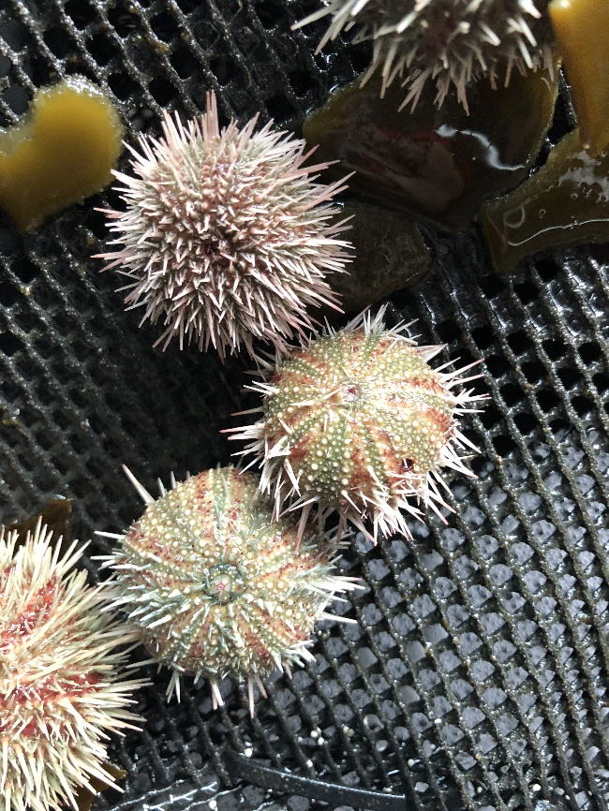

Figure 1: Image of P.angulosus fed Ecklonia maxima dietary treatment taken in week 2 of the experiment.

Diet had a significant effect on survival rate (%) (Kruskal-Wallis, p < 0.001) within the first nine weeks of the experiment (Figure 2). The kelp dietary treatment had a significantly lower (Dunn – Bonferroni test, p < 0.05) survival rate than all other dietary treatments in this period. Many urchins in the kelp dietary treatment group showed severe spine loss and were removed from the tanks for disease and water quality concerns (Figure 1). Due to the consistently poor health during the early stages of the experiment and concerns for the health of the animals, the kelp dietary treatment was suspended in week 9. Kelp dietary treatment urchins were ethically euthanized as per DFFE biosecurity regulation and kelp was removed from the mixed dietary treatment feeding regime. The mixed diet regime changed to Ulva lacinulata and a formulated feed containing 16% Ulva on a weekly basis from week 10 onwards.

Figure 2. Mean (± SE) of survival rate (%) for the Cape sea urchin, P. angulosus, fed different diet treatments (formulated feed with 16% ulva, Ecklonia maxima kelp, Ulva lacinulata, and a combination of the forementioned to form a mixed diet) under different temperature conditions (ambient ~ 15oC and warm ~18oC). Letters above bars represent dietary treatment groups that are significantly different to each other based on Dunn’s test with Bonferroni correction. Hashtags above bars indicate the level of significant difference between temperature treatment groups based on Mann-Whitney U tests (#: p<0.05, ##: p<0.01, ###: p<0.001). No letters or hastags indicate no significant differences.

1.4.2. Somatic growth and feeding rates

The formulated diet feeding regime produced the fastest specific growth rate (SGR) (% growth per day) for whole Cape sea urchin wet weight (g) at the start of the experiment. However, this extreme weight gain trend did not continue for the duration of the experiment. The mixed diet feeding regime produced the fastest specific growth rates for whole Cape sea urchin wet weight (g) and test diameter (mm) overall.

1.4.3. Gonad growth and development

Dietary treatment had a significant effect on gonad development of P. angulosus throughout the experiment (Kruskal-Wallis, p < 0.001). From the first gonad sample timepoint, the algal dietary treatment groups (kelp and ulva) were significantly more mature than the formulated treatment group (Dunn-Bonferroni, p < 0.01). In week 19 and 23, the ulva dietary treatment group continued to be significantly more mature than all other dietary treatment groups (Dunn-Bonferroni, p<0.05). Temperature treatment and sex did not have a significant effect on gonad development.

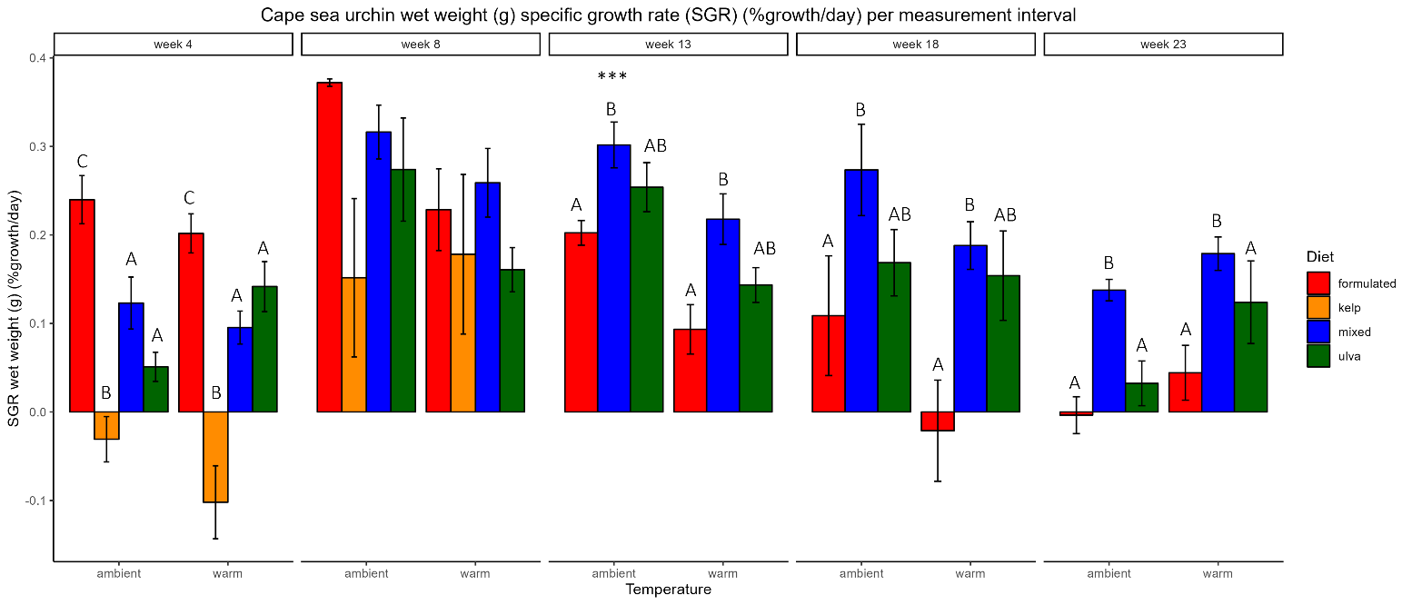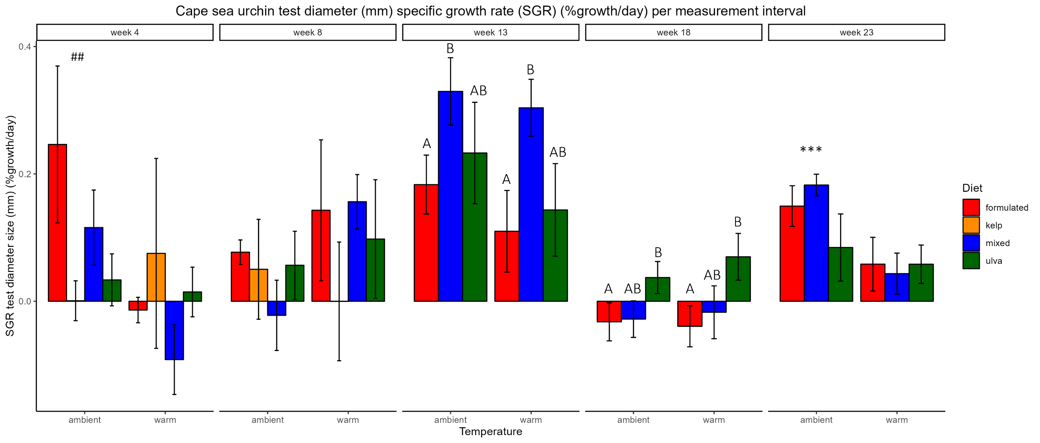

**A**

**B**